CREDIT CARD DATA ANALYSIS-FINAL PROJECT REPORT

TEAM MEMBERS: Tejasvini Shelar, Vineetha Alluri

OBJECTIVE: To collect data, store it in a data warehouse and perform analytics on it to give us meaningful insights.

Steps for the Project:

1. Download Pcard data from data.gov on local system.
2. Load Pcard data from local system to cloudera local file storage using WinSCP at location tmp/sdc:

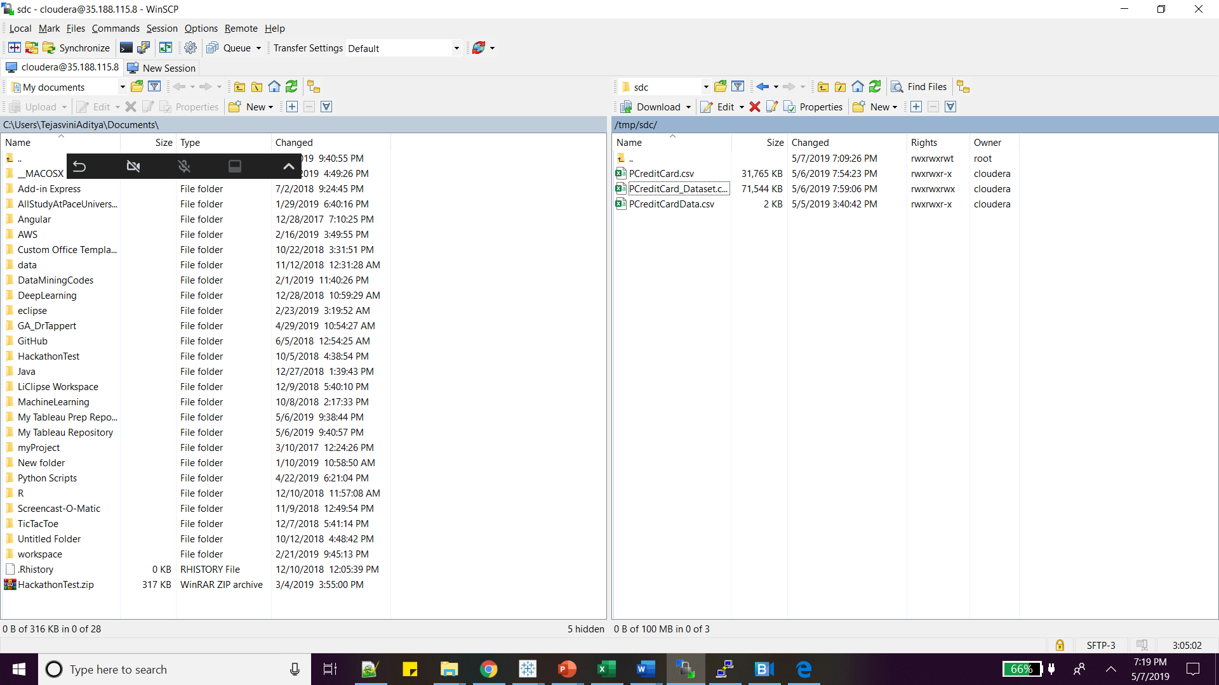

1. Load from cloudera local storage to HDFC using StreamSets:

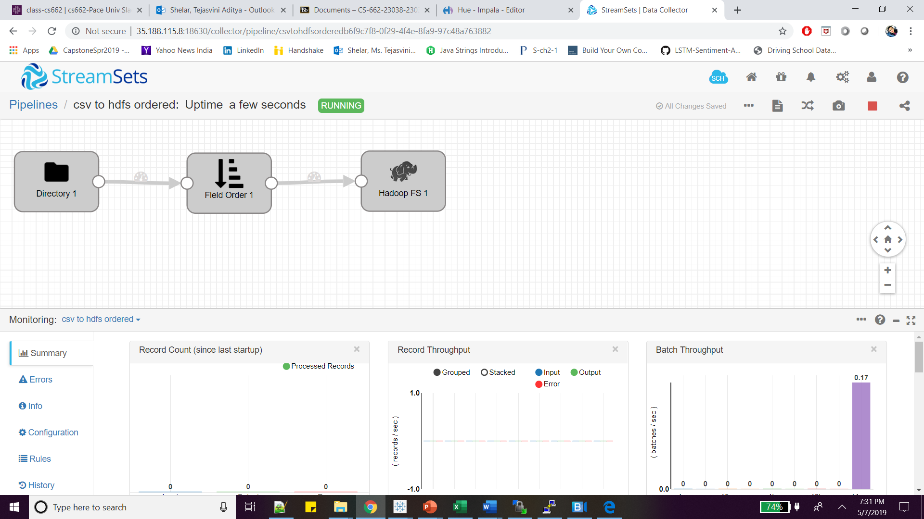

Command to check data in HDFS:

hadoop fs -ls /user/cloudera/ts51786p/

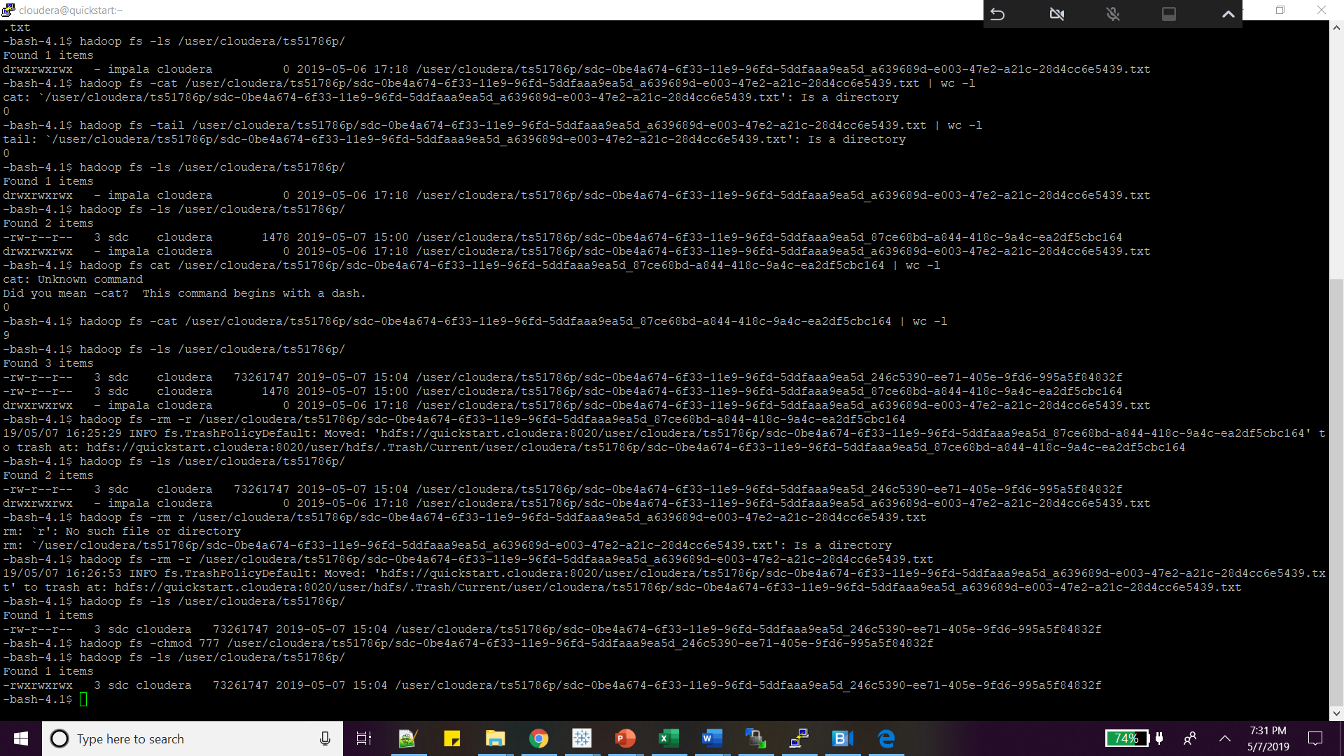

Command to change the access mode of hdfs file:

Hadoop fs -chmod 775 /user/cloudera/ts51786p/sdc-0be4a674-6f33-11e9-96fd-5ddfaaa9ea5d_246c5390-ee71-405e-9fd6-995a5f84832f.txt

1. Create Impala table from HDFS data using below queries:

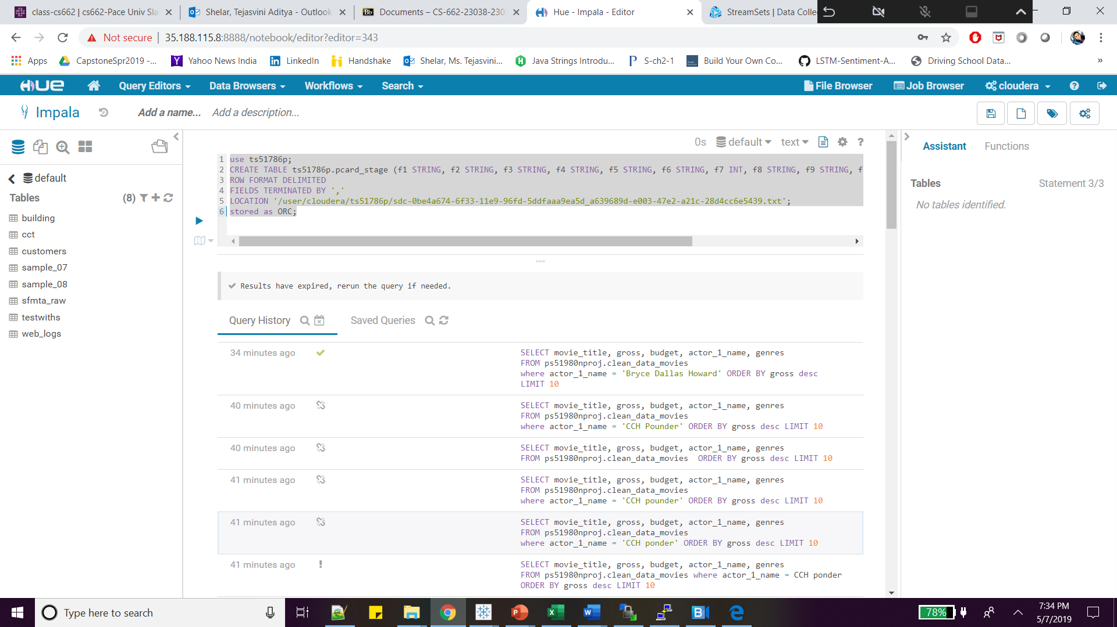

1. Load HDFS data to Impala table as using query:

LOAD DATA INPATH '/user/cloudera/ts51786p/sdc-0be4a674-6f33-11e9-96fd-5ddfaaa9ea5d_a639689d-e003-47e2-a21c-28d4cc6e5439'

INTO TABLE ts51786p.pcard_stage;

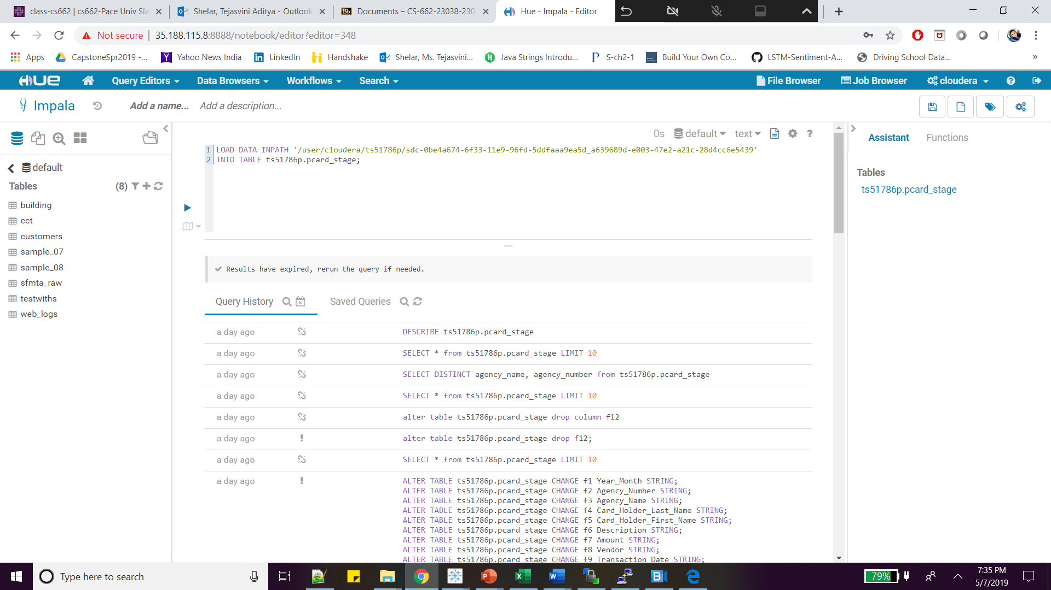

1. Used Tableau for generating different reports of Impala Pcard data table

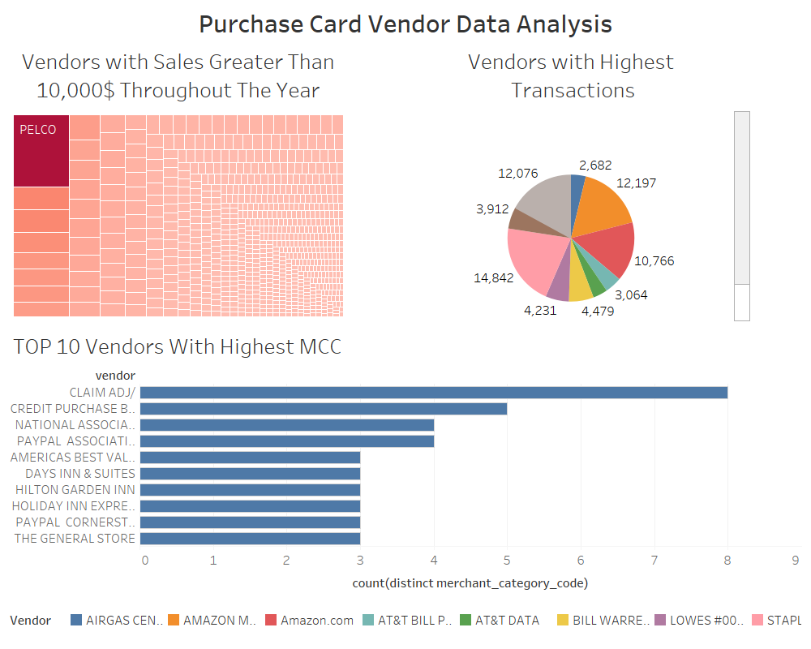

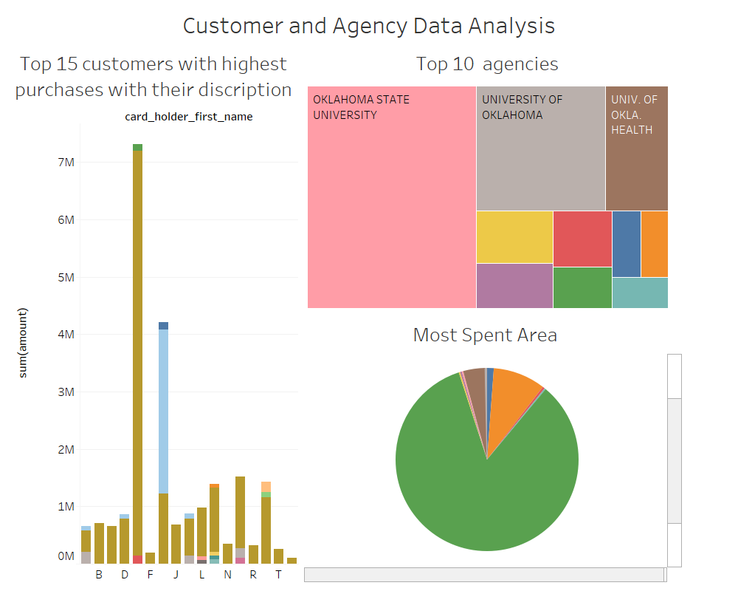

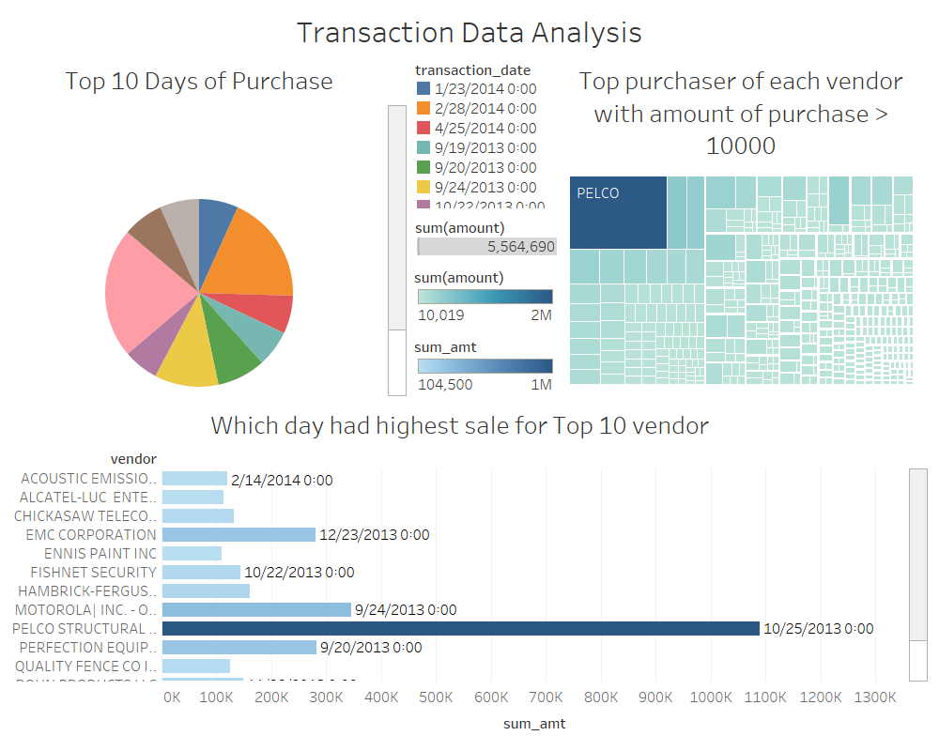

1. Queries for generating reports:

/* top 10 vendors with highest transactions */

select vendor, count(*)

from ts51786p.pcard_stage

group by vendor

having count(*) > 20

order by count(*) DESC

LIMIT 10;

/* top 10 vendors with highest sales */

select vendor, sum(amount)

from ts51786p.pcard_stage

group by 1

having sum(amount)>10000

order by sum(amount) DESC

LIMIT 10;

/* bottom 10 vendors with lowest transactions */

select vendor, count(*)

from ts51786p.pcard_stage

group by vendor

order by count(*) ASC

LIMIT 10;

/* bottom 10 vendors with lowest sales */

select vendor, sum(amount)

from ts51786p.pcard_stage

group by 1

order by sum(amount) ASC

LIMIT 10;

/*Top 10 vendors with highest merchant_category_codes */

select vendor, count(distinct merchant_category_code),group_concat(distinct merchant_category_code)

from ts51786p.pcard_stage

group by vendor

order by count(distinct merchant_category_code) DESC

LIMIT 10;

/*Top 10 purchases with highest sales */

select description, sum(amount)

from ts51786p.pcard_stage

group by 1

having sum(amount)>100

order by sum(amount) DESC

LIMIT 10;

/*Bottom 10 purchases with lowest sales */

select description, sum(amount)

from ts51786p.pcard_stage

group by 1

having sum(amount)> 0

order by sum(amount) ASC

LIMIT 10;

/*Top 10 customers with highest purchases */

select card_holder_last_name, card_holder_first_name, sum(amount)

from ts51786p.pcard_stage

group by 1,2

having sum(amount) > 100

order by sum(amount) DESC

limit 10;

/*top 10 agencies which sold most credit cards*/

select agency_number, agency_name,

count(distinct card_holder_last_name, card_holder_first_name) as count1

from ts51786p.pcard_stage

group by 1,2

having count1 > 1

order by count1 DESC

limit 10;

/*Top purchaser of each vendor with amount of purchase > 10000*/

select card_holder_last_name, card_holder_first_name, vendor, sum(amount)

from ts51786p.pcard_stage

group by 1,2 ,3

having sum(amount) > 10000

order by sum(amount) DESC

/*Top 10 days when purchase was the highest*/

select transaction_date, sum(amount)

from ts51786p.pcard_stage

group by 1

having sum(amount) > 1

order by sum(amount) DESC

LIMIT 10;

/*Which day had highest sale for each vendor*/

select transaction_date, vendor, rank1, sum_amt

from (

select transaction_date, vendor, rank() over (partition by vendor order by sum(amount) DESC) as rank1, sum(amount) as sum_amt

from ts51786p.pcard_stage

group by transaction_date,vendor

having sum(amount) > 1

order by sum(amount) DESC

)a

where rank1 = 1

1. Future Work:

Build normalized data model for data warehouse.

For loading data every month use Oozie job scheduling.

1. Data Modelling

Dimension Table:

|  |
| --- |
| **Card_Provider** |
| agency_Number |
| agency_name |

|  |
| --- |
| **Card_Holder** |
| First_name |
| Last_name |

|  |
| --- |
| **Product_Vendor_Merchant** |
| Description |
| Vendor |
| merchatCC |

Facts Table:

|  |
| --- |
| **Transaction** |
| Amount |
| Transaction_date |
| posted_date |

Conclusion:

We learned how to use different technologies in the course of doing this project. The insights we achieved as a result of it were immensely helpful in understanding the data. Given more time we would like to create facts table, dimension table and also perform more complex analytics.